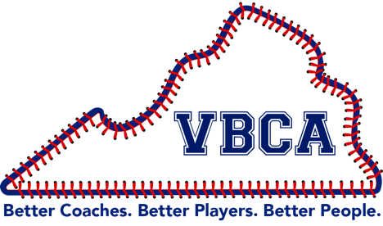
VIRGINIA BASEBALL COACHES ASSOCIATION
VBCA.org
vbca2023@gmail.com
@VBCA2018

VIRGINIA BASEBALL COACHES ASSOCIATION
CONVENTION 2025
RECERTIFICATION CREDIT REQUIREMENTS
December 4, 5, 2025 – University of Virginia,
Charlottesville

Hampton University Online
Spring Session 2026
Virginia Baseball Coaches Association
“Coaching for Baseball Coaches” - 33714 EDUC 684

Course Cost: VBCA Member $175
Credit: 3 Hours, Graduate Level

Course Description: The Virginia Baseball Coaches Association annual convention provides presentations, panel discussions, question and answer sessions, and demonstrations in injury prevention, mental and physical performance, practice organization and instruction in baseball skills, strategy, player development, and evaluation with its primary focus directed to the development of baseball coaches at any level of amateur baseball.

Course Requirements:
- Attend 50% of the Convention presentations including breakout sessions.
- List presentations attended.
- Submit a synopsis of the main theme or takeaways from five (5) of the presentations attended.

Papers must be submitted (preferably typed) by February 1st, 2026 for Spring 2026 semester credit Session IV (March 9-May 8, 2026) to:

Janetta Boone
Hampton University
Assist. Director of Enrollment Management & Registration
JANETTA.BOONE@HAMPTONU.EDU
757-224-0280
https://home.hamptonu.edu/online/

*All payments are taken online. The student will have access to the online portal once they are admitted.

